CTM-I Use Case

Futures Trade Correction

Version 0.1

Use Case Name | Futures Trade Correction
Actor | One Chicago Firm, Market Operations, Operations, App Support
Pre-conditions /Assumptions | User has Browser and is aware of the http path to the application.  User has successfully logged into the CTM-I application.  User has selected a specific trade to correct.
Post Conditions | None
Screenshot | 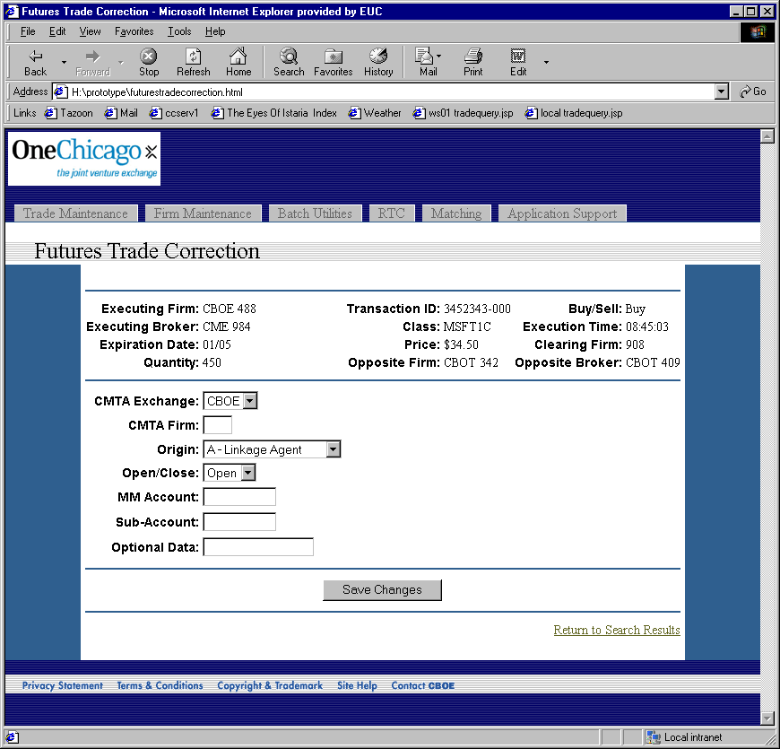
Flow of Events | - Use Case is initiated with a specific Futures Trade  - Futures Trade Correction Screen appears  - The following fields are displayed to the user, with the data from the trade.  - Executing Firm – Firm exchange and firm number  - Executing Broker – Broker exchange and broker  - Expiration Date  - Quantity  - Transaction ID  - Class  - Price  - Opposite Firm – Firm exchange and firm number  - Buy/Sell  - Execution Time  - Clearing Firm – Firm exchange and firm number  - Opposite Broker – Broker exchange and broker  - The following fields are available for the user to correct. Each field is pre-populated with the current data in the trade.  - CMTA Exchange – Limited to “CBOE”, “CME” and “CBOT”  - CMTA Firm  - Origin – Limited to the available Origins  - Open/Close – Limited to “Open” and “Close”  - Market Maker Account  - Sub-Account  - Optional Data  - The user saves changes by pressing the “Save Changes” button.  - The changes are sent to CTM-R for correction  - The screen is redisplayed with the new trade data. Any errors from CTM-R are displayed.
Alternative Path | 1.1 The user can return to the Futures Trade Query Use Case by selecting the link “Return to Search Results”. The last set of criteria the user used to perform a search should be used to re-execute the search and pre-populate the results of the search.

